

Control Tower System Analysis

Table of Contents

Introduction and Working Hypotheses 1

System Description 1

System Behaviour 1

Working Hypotheses 1

System Modelling 2

Queuing Theory Model (attempt) 2

Simulation Model 3

Preliminary Analysis 4

Stability Condition 4

Subsampling and Confidence Level 5

Warm-up Time 6

Statistics Distributions Fitting 7

2kr Factorial Analysis 8

System Fairness Analysis 10

Conclusions 11

Introduction and Working Hypotheses

System Description

The system under analysis consists in an airport with a single runway, which can be used by one airplane at a time for landing or take-off operations, a parking area, where airplanes are temporarily stationed between landing and take-off, and a control tower, which routes the air traffic within the airport.

System Behaviour

The system behaviour can be described as follows:

1. Airplanes intending to land reach the airport with an interarrival time “tA”.
2. Whenever an airplane intending to land reaches the airport, it enqueues for landing waiting for the authorization from the control tower.
3. As soon as authorized by the control tower, the airplane performs the landing operation occupying the runway, which completes in a time “tL”.
4. As soon as the airplane has finished landing it frees the runway and moves towards the parking area, where it will remain stationed for a time “tP”.
5. When the airplane finishes its parking time, it enqueues for take-off, again waiting for the authorization from the control tower.
6. As soon as authorized by the control tower, the airplane performs the take-off operation, occupying the runway, which completes in a time “tO”.
7. When the airplane completes the take-off operation, it leaves the system.

From here the control tower routes the traffic within the airport by authorizing the landing or take-off of the airplane having waited the longest to use the runway, assigning it to the next longest waiter as soon as the airplane completes its landing or take-off.

Working Hypotheses

The system must be analysed under the following given hypothesis:

1. The system must be analysed supposing the “tA” , “tL”, “tP” and “tO” times described above both as constants (deterministic regime) and as rates of exponential random variables (stochastic regime).
2. The airplanes awaiting landing have an infinite fuel supply, meaning that they can wait for an infinite time without the risk of crashing.
3. The parking area has an infinite airplane capacity.

The system analysis will also be based on the following additional hypotheses:

1. The system will be analysed starting from an empty state, meaning that there are no airplanes parked, landing or taking off, and where the first airplane will reach the system in a time “tA”.
2. The airplanes parking time “tP” starts as soon as they leave the runway, and comprises the time required to reach the parking facilities, to perform any passengers/cargo unloading/loading and refuelling, and to leave the parking facilities reaching a separate area adjacent to the runway, where they will wait for the authorization to take-off from the control tower. Following this description, the total number of grounded planes within the airport is given by the number of parked airplanes plus the number of airplanes enqueued for take-off.
3. Should two airplanes be ready for landing and take-off at exactly the same time (which may occur both in deterministic and stochastic regimes, in the latter case due to quantization roundings), the Control Tower will assign the runway to the airplane requesting to land.
4. The system time evolution strictly attunes to the behaviour described above, where real case delays such as the ones determined by the communications between the airplanes and the control tower, the ignition time of the engines prior to take-off, or the local spatial displacements of the airplanes awaiting landing or take-off are not taken into account.

System Modelling

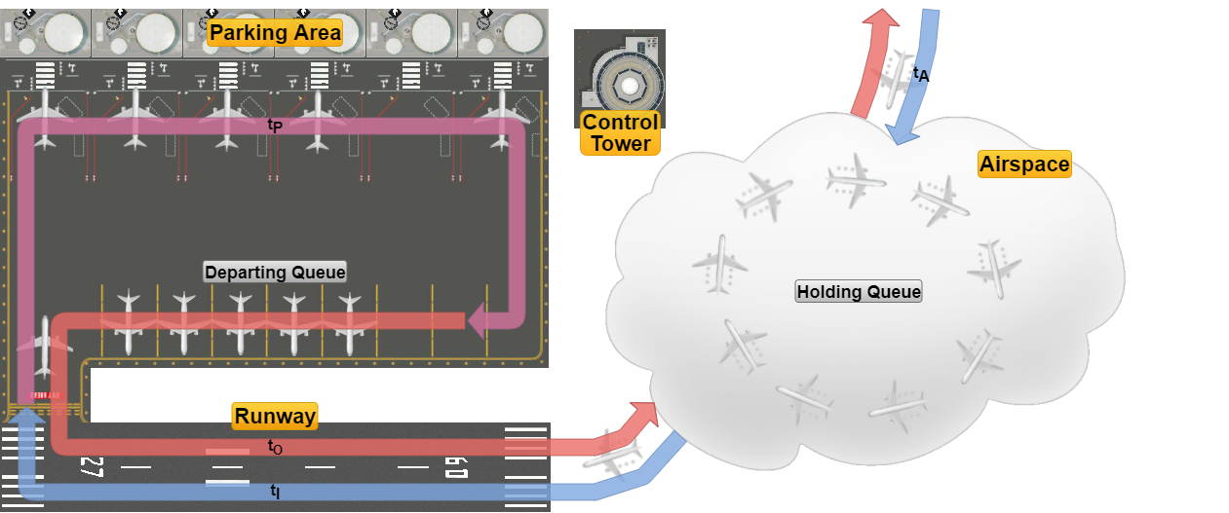

The system can be functionally divided into the following components:

* The *Airspace* surrounding the airport, where the airplanes intending to land arrive with an interarrival time “tA” and enqueue for landing in the *Holding Queue*, and where airplanes transit once they have taken off, leaving the system.
* The *Runway*, which is used mutually exclusively by airplanes for landing and take-off operations, which are performed in times “tL” and “tO” respectively.
* The *Parking Area*, which consists of the facilities where the airplanes transit through after they have landed and before they are ready for take-off, which occurs in a time “tP”, after which the airplanes enqueue in a separate *Departing Queue* adjacent to the runway waiting for the authorization to take-off.
* The *Control Tower*, which acts as a logical entity routing the traffic within the airport.

Queuing Theory Model (attempt)

The system can be tentatively described in terms of queuing theory as a classed routing network with the jobs representing airplanes divided into the two classes as follows:

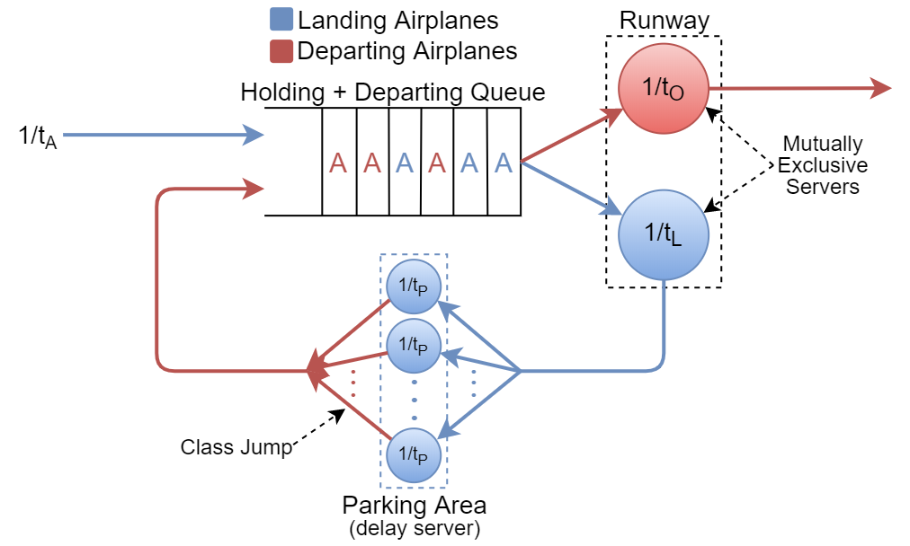

Where:

* The *Holding* and *Departing* *Queues* have been logically merged into a single virtual queue having as server the *Runway*, which in turn is divided into two logical servers with service rates ““ and ““ relative respectively to the landing and departing classes, servers whose services are mutually exclusive (i.e. just one airplane at a time can be served in the runway by the virtual server associated with its class).
* The *Parking Area* represents a *Delay Server* with service rate “”, which also switches the airplanes from the Landing to the Departing class.  
  It should also be noted that, representing a Delay Server, the *Parking Area*’s parking time “tP” will have no effect on the system’s stability, as is thoroughly discussed later in the document.
* The *Control Tower*, being a logical entity, finds no correspondence in the model.

From here, since we are unable to determine the steady-state equations of the network and thus its performance metrics, in order to analyse the system the use of a simulation software is required.

Simulation Model

The simulator software used is OMNeT++ 5.5.1, wherein the system model was reproduced as follows:

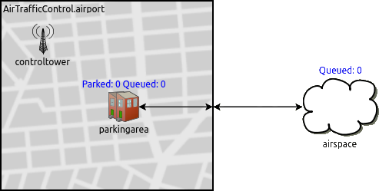

Where:

* The *airspace*, the *parkingarea* and the *controltower* represent simple modules, the last two being logically grouped inside an *airport* compound module representing the airport grounds.
* The *runway* represents the connection between the *parkingarea* (and the *airport* module) and the *airspace*.
* The *controltower* acts again as a logical module that doesn’t exchange messages (i.e. airplanes) with the others, and being the communication delays between the tower and the airplanes not taken into account (hypothesis 6.), the synchronizations between the landing/departing airplanes and the control tower are performed via cross-module calls, where each time a landing/take-off is completed the control tower assigns the runway to the airplane with the longest waiting time in the *Holding Queue* (*airspace*) and the *Departing Queue* (*parkingarea*).

The results that follow were obtained through the sampling of the following quantities during the system time evolution:

* The number of airplanes waiting in both queues (*Holding Queue Size* and *Depart Queue Size*).
* The airplanes’ waiting times in both queues (*Holding Queue Waiting Time* and *Depart Queue Waiting Time*).
* The number of parked airplanes (*Parked Planes*).
* The system total response time (*Airport Response Time*).

Preliminary Analysis

Stability Condition

Following our tests, we determined the stability condition of the system to be:

tA > tL + tO

Which expressed in terms of interarrival rate and service rates and becomes:

Meaning that the overall system presents an equivalent service rate of:[1]

Moreover, the utilization factor of the system is given by:

Below are shown instances of the trends of the main system statistics [or just AirportResponseTime?], both under stability and instability and in deterministic and exponential regime acting as an empirical confermation of the results above.

**Parametri? Mi raccomando uguali a quelli dopo a parte tA che sale di poco**

System Instability (tA < tL + tO)

|  |  |
| --- | --- |
| **Deterministic Regime**    **PLACEHOLDER** | **Exponential Regime**   |

As shown by the plots above, if tA < tL + tO the *AirportResponseTime* diverges in both regimes, compelling evidence of an unstable system.

System Stability (tA > tL + tO)

**Diminuire raggio punti**

|  |  |
| --- | --- |
| **Deterministic Regime**  **PLACEHOLDER** | **Exponential Regime**    **Qualcosa sulle code?** |

If tA > tL + tO we can observe that:

* In Deterministic Regime the *AirportResponseTime* approaches the value ART = tL + tO + tP, while the mean size of both queues drops to “0” while their maximum size caps at “1”, which as better discussed later is due to the conflicting utilization of a single shared resource (the *Runway*) by two modules (The *Holding* and the *Departing Queues*).

**Riscrivere a seconda dei grafici**

* In Exponential Regime we can preliminarily observe the quantities to be strongly correlated, both with themselves (*autocorrelation*) and with the others, in particular the *Waiting Time* and the *Size* of both queues and the *Waiting Time* of both queues with the *AirportResponseTime*. [Verificare, aggiungere, correggere].

From here, since the statistics trends do not diverge as the sample size (and thus the simulation time) increases, we can assert the system to be stable, thereby proving the aforementioned stability condition.

Subsampling and Confidence Level

As is outlined in the plots above, all the samples of the system statistics (with the exception of the *Parked Planes*) present a strong degree of autocorrelation, thus, in order to allow us to properly define the degree of confidence of the results of our further analyses, an iterative subsampling process was applied to each statistic dataset, to ensure the IID-ness of the samples and thus derive from the initial sample width “N” the effective sample width “Neff“ that will be used in the computation of our confidence intervals, which will be taken with a confidence level of 95% (α = 0.05).

**Da notare che abbiamo sempre usato un numero di campioni N>numero min per una confidenza del   
95% (vedi slide pag.36)  
Abbiamo usato la S (sample standard deviation) più alta rilevata, sempre fisso numero di aerei (scrivere due righe, Luigi)**

**a**

The iterative subsampling process used is described in the pseudo-code below:



Where the IID-ness of the samples in each dataset was tested by checking that all sample autocorrelation coefficients have an absolute value of less than the ±zα/2/√N for each possible lag.

We also noticed the degree of autocorrelation in the datasets to be directly affected by the system utilization factor ρ, with higher values of the latter causing higher degrees of autocorrelation, thus lowering the resulting effective sample widths “Neff” given the same initial sample widths “N”, as is shown in the trend instances below:

|  |  |
| --- | --- |
| **Low Utilization (ρ = 0.33)** | |
| **Before Subsampling**    N = 100.000 | **After Subsampling**  NEFF = 164 |
| **High Utilization (ρ = 0.75)** | |
| **Before Subsampling**    N = 100.000 | **After Subsampling**  NEFF = 111 |

Warm-up Time Study

From our analyses and referring to the equivalent QT model we concluded that the system’s warm-up time corresponds to the time required by the mean throughput of airplanes on the feedback loop, represented by the parking area, to stabilize, which depends with different weights on all the system parameters (tA, tL , tP, and tO).

Deterministic Warm-up Time

In deterministic regime we deduced the system’s warm-up time to coincide with the time the first airplane finishes its parking time and enqueues in the *Departing Queue*, which occurs at the time:

tWARM-UP = tA + tL + tP

Furthermore at this instant, under the stability condition, since no airplane has yet taken off from the airport, the “transient” contribution of the departing service time “tO“ to the overall service time will be null, from which, by considering the stability condition:

tA > tL + tO ⇒ tA > tL ⇒ λA < µL

Which allows us to assert that in deterministic regime at the warm-up time tWARM-UP = tA + tL + tP, with the only exception of an airplane enqueuing in the *Holding Que*ue at the same instant, such queue will be empty, one airplane might be landing, and thus the first airplane exiting the parking area will be the next to use the runway for take-off.

Exponential Warm-up Time

In exponential regime, due to the randomness of the system parameters, the previous results are invalid, and although we tested some empirical formulas in an attempt to estimate the warm-up time as the sum of the parameters’ mean values multiplied by a constant, such as:

tWARM-UP = k(tA + tL + tP + tO) k ∈ ℕ

due to inconsistencies in the results we finally settled on selecting the warm-up time in exponential regime using a more rigorous approach outside the Omnet++ simulation environment, where, considering the *Airport Response Time* as the most comprehensive statistic in our system and by using N=100 different RNG seeds, for each given configuration tA, tL, tP, and tO we selected the warm-up time as the maximum time at which the ART samples differ from their mean value by less than two orders of magnitude of their standard deviation for a consecutive number of samples, where two examples of computations are depicted in the plots below:

|  |  |
| --- | --- |
|  | **Aggiornare con immagini con <figcaption> e corrette “]” (Nicola)** |

Statistics Distributions Fitting

The next step in our analysis consisted, in exponential regime and under the stability condition, in determining the distribution families the statistics in our system belong to, fitting whose results are shown in the QQ-plots below:

|  |  |  |
| --- | --- | --- |
| **Holding Queue Size**  Geometric Distribution | **Depart Queue Size**  Geometric Distribution | **Parked Planes**  Poisson Distribution |
| **Holding Queue Waiting Time**  Exponential Distribution | **Depart Queue Waiting Time**   Exponential Distribution | **Airport Response Time**  Hypoexponential Distrib. |

Once the distributions were fitted, to better understand their relationships, we also attempted to estimate their parameters for a particular configuration through the use of their **Maximum Likelihood Estimator (MLE)[2]**, as shown below:

|  |  |  |
| --- | --- | --- |
| Statistic | Distribution | Maximum Likelihood Estimator |
| Holding Queue Size  Depart Queue Size | Geometric |  |
| Holding Queue Waiting Time  Depart Queue Waiting Time | Exponential |  |
| Parked Planes | Poisson |  |
| Airport Response Time | Hypoexponential |  |

|  |  |
| --- | --- |
|  |  |

|  |  |  |
| --- | --- | --- |
| **Holding Queue Size** | **Depart Queue Size** | **Parked Planes** |
| **Holding Queue Waiting Time** | **Depart Queue Waiting Time** | **Airport Response Time** |

Where the main observation that can be derived from the values of the parameters is that the *Holding Queue Size* and the *Depart Queue Size*, as well as the *Holding Queue Waiting Time* and the *Depart Queue Waiting Time*, present the same distributions with approximately the same values, providing additional evidence that both queues behave as a single logical queue as predicted in the system equivalent QT model.

2kr Factorial Analysis

Next, to better understand the contributions of the parameters tA ,tL, tP and tO, we performed a 2kr factorial analysis using 500 replications for each configuration, for a total of 24*500 = 8000 simulations, whose results are shown below (where the combinations of parameters having a null contribution for each statistic have been omitted for clarity):

Holding Queue Size (HQS)

|  |  |  |  |  |  |  |  |  |  |  |
| --- | --- | --- | --- | --- | --- | --- | --- | --- | --- | --- |
|  | MP | tA | tL | tA tL | tO | tA tO | tL tO | tA tL tO | tP | other |
| **q** | 0.841 | -0.412 | 0.361 | -0.244 | 0.342 | -0.23 | 0.153 | -0.145 | 0.0008 | … |
| **SS** | 5.66e3 | 1.36e3 | 1.03e3 | 4.76e2 | 9.36e2 | 4.22e2 | 1.87e2 | 1.68e2 | 0.0056 | … |
| **Impact** | - | **29.58%** | **22.67%** | **10.37%** | **20.41%** | 9.19% | 4.09% | 3.67% | 0.00% | 0.00% |
| SST = 4.59*103 | | | | SSE = 0.901 | | | SSE/SST = 0.02% | | | |

Depart Queue Size (DQS)

|  |  |  |  |  |  |  |  |  |  |  |
| --- | --- | --- | --- | --- | --- | --- | --- | --- | --- | --- |
|  | MP | tA | tL | tA tL | tO | tA tO | tL tO | tA tL tO | tP | other |
| **q** | 0.829 | -0.408 | 0.391 | -0.255 | 0.312 | -0.218 | 0.165 | -0.149 | 0.0015 | … |
| **SS** | 5.5e3 | 1.33e3 | 1.22e3 | 5.2e2 | 7.77e2 | 3.82e2 | 2.18e2 | 1.78e2 | 0.018 | … |
| **Impact** | - | **28.73%** | **26.42%** | **11.24%** | **16.78%** | 8.25% | 4.71% | 3.84% | 0.00% | 0.00% |
| SST = 4.63*103 | | | | SSE = 0.905 | | | SSE/SST = 0.02% | | | |

Holding Queue Waiting Time (HQWT)

|  |  |  |  |  |  |  |  |  |  |  |
| --- | --- | --- | --- | --- | --- | --- | --- | --- | --- | --- |
|  | MP | tA | tL | tA tL | tO | tA tO | tL tO | tA tL tO | tP | other |
| **q** | 29.4 | -17.0 | 18.3 | -12.5 | 17.4 | -11.9 | 9.99 | -8.58 | 0.0427 | … |
| **SS** | 6.91e6 | 2.32e6 | 2.67e6 | 1.25e6 | 2.41e6 | 1.13e6 | 7.98e5 | 5.89e5 | 14.6 | … |
| **Impact** | - | **20.81%** | **23.91%** | 11.20% | **21.56%** | 10.09% | 7.14% | 5.27% | 0.00% | 0.00% |
| SST = 1.12*107 | | | | SSE = 2.25*103 | | | SSE/SST = 0.02% | | | |

Depart Queue Waiting Time (DQWT)

|  |  |  |  |  |  |  |  |  |  |  |
| --- | --- | --- | --- | --- | --- | --- | --- | --- | --- | --- |
|  | MP | tA | tL | tA tL | tO | tA tO | tL tO | tA tL tO | tP | other |
| **q** | 29.1 | -17.0 | 19.0 | -12.8 | 16.7 | -11.6 | 10.3 | -8.67 | 0.0791 | … |
| **SS** | 6.76e6 | 2.3e6 | 2.88e6 | 1.3e6 | 2.22e6 | 1.08e6 | 4.49e5 | 6.02e5 | 50.1 | … |
| **Impact** | - | **20.47%** | **25.60%** | 11.60% | **19.79%** | 9.60% | 7.55% | 5.36% | 0.00% | 0.00% |
| SST = 1.12*107 | | | | SSE = 2.25*103 | | | SSE/SST = 0.02% | | | |

Parked Planes (PP)

|  |  |  |  |  |  |  |  |  |  |  |
| --- | --- | --- | --- | --- | --- | --- | --- | --- | --- | --- |
|  | MP | tA | tL | tA tL | tO | tA tO | tL tO | tP | tA tP | other |
| **q** | 1.71 | -0.303 | -0.015 | 0.0079 | 0.0149 | -0.0079 | -0.0069 | 0.399 | -0.0997 | … |
| **SS** | 2.33e4 | 7.37e2 | 1.79 | 0.51 | 1.77 | 0.503 | 0.376 | 1.28e3 | 79.5 | … |
| **Impact** | - | **35.15%** | 0.09% | 0.02% | 0.08% | 0.02% | 0.02% | **60.82%** | 3.79% | 0.00% |
| SST = 2.1*103 | | | | SSE = 0.0373 | | | SSE/SST = 0.00% | | | |

Airport Response Time (ART)

|  |  |  |  |  |  |  |  |  |  |  |
| --- | --- | --- | --- | --- | --- | --- | --- | --- | --- | --- |
|  | MP | tA | tL | tA tL | tO | tA tO | tL tO | tA tL tO | tP | other |
| **q** | 1.83e2 | -34.0 | 44.7 | -25.3 | 41.5 | -23.5 | 20.3 | -17.3 | 30.1 | … |
| **SS** | 2.69e8 | 9.25e6 | 1.6e7 | 5.11e6 | 1.38e7 | 4.41e6 | 3.29e6 | 2.38e6 | 7.26e6 | … |
| **Impact** | - | **15.04%** | **26.02%** | 8.31% | **22.42%** | 7.17% | 5.35% | 3.87% | **11.8%** | 0.00% |
| SST = 6.15*107 | | | | SSE = 9.2*103 | | | SSE/SST = 0.01% | | | |

From here, before computing the confidence intervals of our results, we have checked the residuals to be normally distributed with a null mean and a constant standard deviation, hypothesis which results verified exclusively for the *Parked Planes*, as shown below:

**X LUIGI  
I discorsi sugli errori/residuals nella 2kr analysis iniziano qui, vedi se ti piacciono e cosa eventualmente modificare**

|  |  |
| --- | --- |
| **Parked Planes Residuals Analysis** | |
| **Residuals QQ-Plot** | **Residuals vs Predicted Response** |

Where the trends appearing in the plot of the residual against the predicted response can be ignored, being the former less than one order of magnitude than the latter, which allowed us to compute the following confidence intervals of the results relative to the *Parked Planes*:

Parked Planes (confidence intervals)

|  |  |  |  |  |  |  |  |  |  |
| --- | --- | --- | --- | --- | --- | --- | --- | --- | --- |
|  | MP | tA | tL | tA tL | tO | tA tO | tL tO | tP | tA tP |
| **q** | 1.71 | -0.303 | -0.015 | 0.0079 | 0.0149 | -0.0079 | -0.0069 | 0.399 | -0.0997 |
| **CI** | (1.71,  1.71) | (-0.304,  -0.303) | (-0.015,  -0.0149) | (0.00794,  0.00803) | (0.0148,  0.0149) | (-0.00798,  -0.00788) | (-0.0069,  -0.0068) | (0.399,  0.399) | (-0.0997,  -0.00996) |

As for the other statistics, while their residuals being not normally distributed prevents us from computing the confidence intervals on the results, they don’t undermine their validity, having the errors a very low standard deviation and skewness, other than a mean value more than one orders of magnitude less than the mean values of the observed quantities, as is summarized in the table below:

**X LUIGI  
Vedi te se vuoi mettere anche gli istogrammi, ma mi sembra che il punto l’hai fatto capire, anche per motivi di spazio**

|  |  |  |  |  |  |  |
| --- | --- | --- | --- | --- | --- | --- |
|  | Holding Queue Size | Depart Queue Size | Holding Queue Waiting Time | Depart Queue Waiting Time | Parked Planes | Airport Response Time |
| **Mean** | -1.7766e-18 | 7.5939e-17 | 1.5916e-15 | -1.0374e15 | 1.65e-16 | -1.3898e-14 |
| **Std. Dev.** | 0.0106 | 0.0106 | 0.5299 | 0.53 | 0.0022 | 1.0722 |
| **Skewness** | -0.1055 | -0.1245 | -0.135 | -0.1688 | -0.0572 | -0.139 |
| **Min** | -0.0955 | -0.095 | -4.9187 | -4.793 | -0.0116 | -9.773 |
| **Max** | 0.0836 | 0.0809 | 4.2121 | 4.0917 | 0.011 | 8.3428 |
| **25th perc.** | -0.0012 | -0.0012 | -0.0416 | -0.039 | -0.0012 | -0.1263 |
| **Median** | -2.6484e-5 | -3.6922 | 0.0002 | -0.0001 | 1.647e-5 | 0.0015 |
| **75th perc.** | 0.0012 | 0.0013 | 0.043 | 0.04 | 0.0013 | 0.1294 |

In conclusion, the main insights that can be derived from the 2kr analysis are:

* Most of the system statistics are affected, with different weights, only by the parameters involved in the stability condition (tA, tL and tO), while the tP only affects the *Parked Planes* and to a minor degree the *Airport Response Time*.

**Dopo di qui metterei l’analisi dei Parked Planes vs tP/tL**

* The *Parked Planes* statistic is affected almost exclusively by the tP and tA parameters.

System Fairness Analysis

From the analysis of their trends we observed all the system statistics (except for the *Parked Planes*) to be strongly correlated, where localized delays or anticipations at any point of the parameters tA ,tL, tP and tO propagates affecting all system statistics, leading to shared trends with alternating spikes of high and low values, representative respectively of a congested and an almost-empty system.  
Aiming at better understanding this behaviour we carried out an analysis on the *fairness* of the system statistics, which in general is affected by the following two factors:

**X Nicola  
Per come è venuto fuori il discorso (e per non farla troppo lunga in tutti i sensi) eviterei sia di dire che la LCG è poco influenzata dall’ordine di grandezza dei parametri, sia eviterei il grafico della LCG di somme di esponenziali**

1. The system’s utilization factor ρ.
2. The relative impacts on each statistic of the parameters tA ,tL, tP and tO and their *likeliness*.  
   This is due to the fact that the more a statistic is affected by multiple parameters with comparable weights, the higher the level of fairness of the statistic, behaviour that can be explained as a progressive influence of the *Central Limit Theorem* (CLT) on such statistic, where, as the number of influencing RVs increases, so do the combination of their contributions tend to a normal distribution, which by nature presents an higher lever of fairness with respect to exponential distributions, and the more such parameters are comparable in value the higher the progressive contribution of the CLT.

Queues Waiting Time Fairness

The fairness of the waiting times in the two queues is an information that can be of relevance for the system users (i.e. the passengers and the air companies), and limiting our analysis to a single queue (since we previously asserted both to behave the same as a single logical queue), we observed the fairness of the waiting times to mainly depend on the utilization factor ρ, as shown by the values of the Lorenz Curve Gap (LCG) in the plot below:

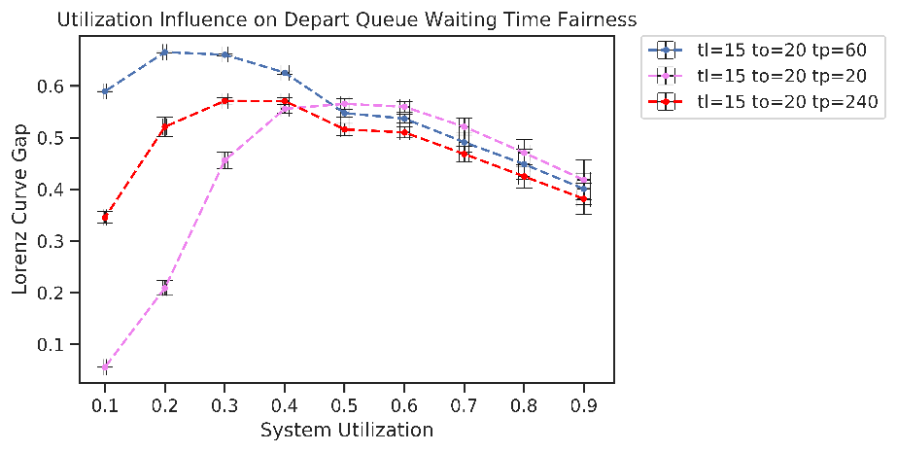

In the plot we can observe that initially the waiting time fairness decreases as the utilization increases, up to a threshold of ρ ≈ 0.4 where the trend inverts, where more utilization leads to more fairness in the waiting times, behaviour that can be attributed to the fact that up to a certain utilization level the airplanes have comparable probabilities of finding the queues in a congested or an almost-empty state, while beyond such threshold most airplanes will experience congested queues, leading to an overall higher fairness in their waiting times.

Airport Response Time Fairness

The fairness of the overall system response time is an information relevant for the airport management,  
[???]

Number and likeliness of the influencing parameters (RVs)

We observed that the more a statistic is affected by multiple parameters, the more such statistic tends to present a higher level of fairness (or a lower LCG) with respect to other statistics influenced by less parameters.  
This behaviour can find explanation as an increasing influence of the Central Limit Theorem (CLT) on the statistics, where as the number of influencing RVs increases, so do their combined effects tend to a normal distribution, presenting an innate higher level of fairness with the respect to exponential distributions.   
We also observed that, for a given number of influencing RVs for a statistic:

1. The more their distributions are similar, the higher the statistic’s fairness, effect that once again finds explanation in the CLT.
2. The statistic fairness is minimally affected by the magnitude of the influencing RVs.

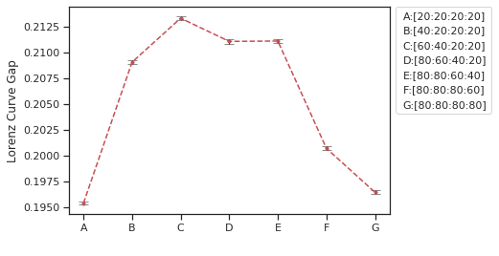Results that are shown in the following plot of the *Airport Response Time* by varying the parameters in the system

**Intestazioni grafico, nel caso se possibile rimuovere introduzione in giallo**

**Questo non c’entra un cazzo col sistema, è solo un esempio**

Utilization Factor ρ

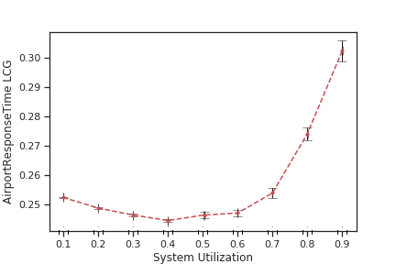We also observed the statistics’ fairness to be directly affected by the system’s utilization factor, where as it increases so does the LCG and so the unfairness, behaviour that can be attributed to the fact that the more the system is congested the more the delay at each of its stage tend to escalate, leading to chains of increasing delays.

**Io mi fermerei qui sui ragionamenti della Fairness.  
1) Quanto può essere accurato che diminuisca intorno a ρ=0.4?  
2) Il comportamento della dimensione delle code andrebbe a invalidare il precedente ragionamento, come si giustifica?**

**Migliorare intestazioni grafico**

**Scrivere qualche cazzatina di conclusione**

Conclusions

Scrivere conclusioni, o direttamente agglomerare qui la maggior parte degli insights dei punti precedenti, e qualche discorso su come aumentare le prestazioni del sistema, tra cui

1. Cercare di ridurre più possibile la randomness (cosa applicata nel reale, cioè ogni aereo ha un suo orario di arrivo e partenza, dove si cerca di limitare la varianza quanto possibile)
2. Possibilmente prevedere più code, dove (sicuramente?) il service rate del sistema cresce linearmente.

Si lascia perdere l’analisi del tempo di ritorno medio del sistema allo stato iniziale?

* As will be further confirmed in the next section, the rate of the poissonian representing the parked planes is approximately equal to λ = tA/tP, which allows us to esteem the number of parked planes in the system and thus the size required by the parking area relaxing the constraint of it having an infinite airplane capacity.

1. A mathematical analogy of the expression of the equivalent service rate can be found in electric networks theory as the equivalent conductance of the parallel of two conductances
2. Introduction to Probability and Statistics for Engineers and Scientists – S. M. Ross